SGA & ARH

Candidate

Profiles

SGA Executive Ticket

(President, Vice-President, & Chief of Staff)

SGA Executive Ticket I
President | Vice President | Chief of Staff
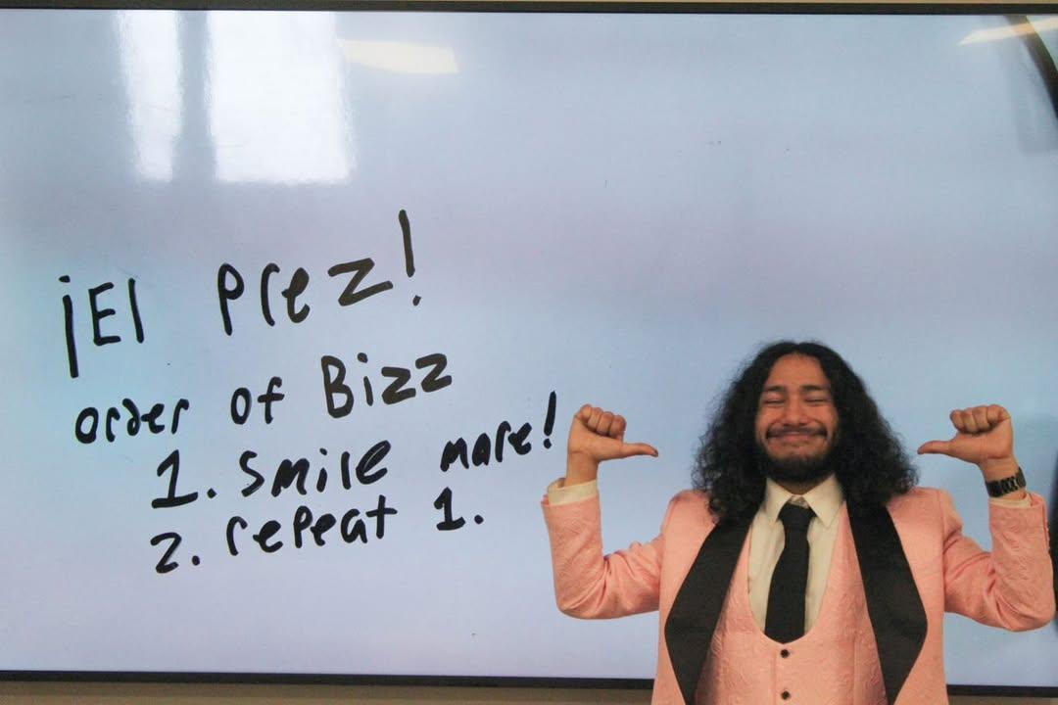 |  | 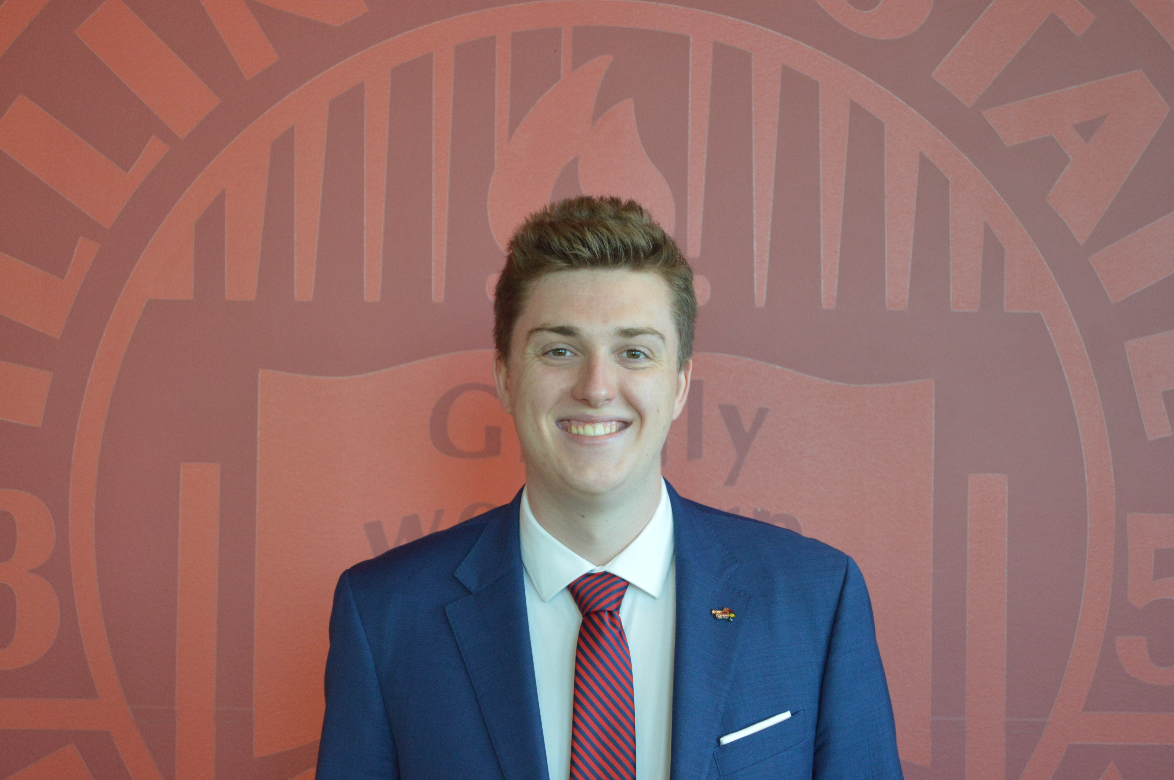
Name: Noah Montoya | Name: Alondra Zagal | Name: Sam Majka
Major: Public Culture and Advocacy Communications | Major: Public Relations | Major: Accelerated Political Science Graduate Program

President Blurb: I am running for Student Body President to build a campus where every Redbird has a call, and every voice is heard. My experience as Vice Speaker of the Assembly and Student Life Senator has been dedicated to representing students, spreading access to resources, and empowering students to take charge of their college experience. By fostering inclusivity, transparency, and engagement, we can create a stronger and more connected ISU where every student feels supported, informed, and inspired to make an impact.
Vice President Blurb: I am a sophomore dedicated to making a difference on campus through my involvement in SGA and Alpha Delta Pi, where I serve as Director of Alumnae Engagement. I am currently an Off-Campus Senator, where I have worked to represent students and their concerns, and I am running for Vice President to continue advocating for meaningful change. I am committed to ensuring all students feel heard and supported while fostering a positive campus environment. With my experience and passion for student leadership, I am ready to take on this role and work for you!
Chief of Staff Blurb: Sam Majka is an experienced, dedicated servant to the ISU community. Having served as the Secretary of Governmental Relations in the Student Government Association for almost two years, and on the Illinois Board of Higher Education for one, Sam has gained deep insight into student issues on campus and in the state of Illinois. Sam also had the opportunity to intern at the Town of Normal, where he learned how to effectively manage multiple projects in a professional capacity. In these roles, Sam has come to admire initiative-taking and professional management, values that he aims to uphold if elected Chief of Staff.

SGA

Senators

College of Applied Science and Technology (CAST) Senator I
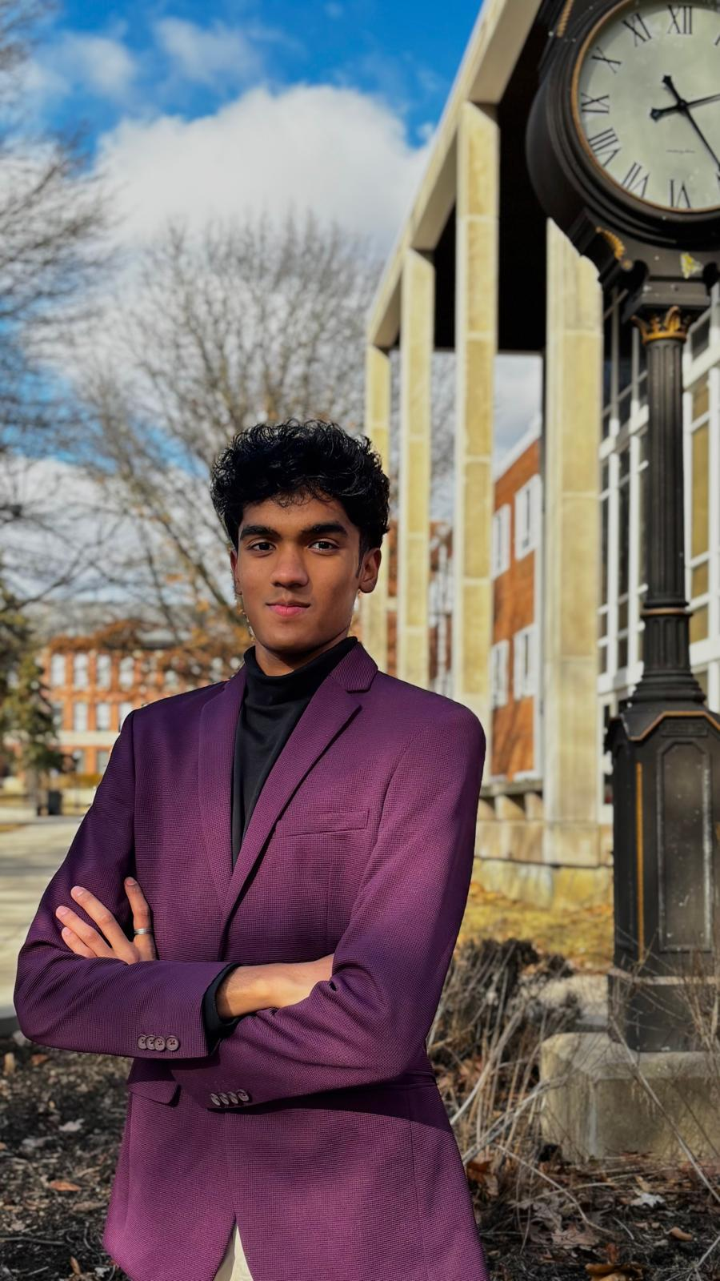
Name: Neer Jain
Major: Computer Science
Blurb: I am a dedicated leader, innovator, and problem-solver, running to be the next CAST Senator. As President of ISU’s ITSA, one of the largest IT organizations on campus, I have successfully led major initiatives, including the IT Internship Fair, connecting students with top industry professionals. As the IT Student Representative for the CAST Council, I strive to strengthen the connection between this Council and SGA, ensuring student voices are heard. Recognized for my passion in technology and research, I was also featured in ISU News. I am committed to advocating for better resources, fostering student success, and driving meaningful change.

College of Applied Science and Technology (CAST) Senator II

Name: Tomas Cottingham

College of Arts and Sciences (CAS) Senator I
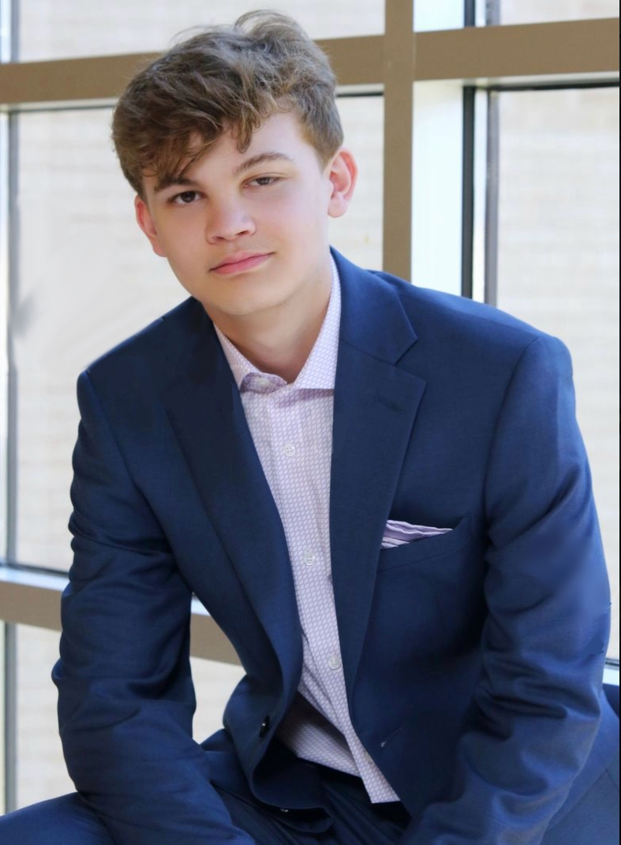
Name: Joseph Polizzi
Major: Political Communications
Blurb: Over the past semester, I’ve learned and heard the issues of countless students in the College of Arts and Sciences. I’m running for re-election as the College of Arts and Sciences Senator to continue to work for the students of ISU by working towards making SGA more democratic, representing the interests of CAS, and advocating students' needs on issues like affordability, civic engagement, and convenience. I hope I can continue to serve and continue the work I’ve begun in my first term.

College of Arts and Sciences (CAS) Senator II

Name: Kathryn Schleder
Major: Legal Studies and Political Science
Blurb: Kathryn is a junior at Illinois State University. She is double majoring in Legal Studies and Political Science while minoring in Spanish. As an Academic Senator, Kathryn would speak on behalf of College of Arts and Sciences students in legislative assemblies. She will push legislation that prioritizes the student’s success in academia. One of her foremost concerns is reconstructing the General Education Program. Kathryn wishes to revise the GenEd program in a way that general education courses are more suitable to one’s major.

College of Fine Arts and Mennonite College of Nursing (CFA/MCN) Senator I

Name: Angel Trader

College of Business (COB) Senator I
Name: Joshua Sweedler

College of Education (COE) Senator
No Candidates

Graduate School Senator I

Name: Jazmine Benson
Major: Political Science
Blurb: Jazmine Benson is an accelerated graduate student within the department of Politics and Government. She currently serves as head delegate of ISU’s Model United Nations team and works at the Center of Civic Engagement. Having served as a Resident Assistant (RA) for 5 semesters, Benson is no stranger to community leadership and advocacy. As Graduate Senator, she strives to promote a genuine and symbiotic connection between graduate students, faculty and the university administration. Academically, Benson plans to pursue a PhD in Political Science post-graduation. She currently has one publication discussing political satire and Alternative Right memes.

Watterson Towers Senator I

Name: Lennon Stoner
Major: Psychology
Blurb: My main goal for the Watterson community is to bring people together. Making connections is a huge part of college, and it starts with the people who you live with and are around nearly 24/7.

Cardinal Court Senator I
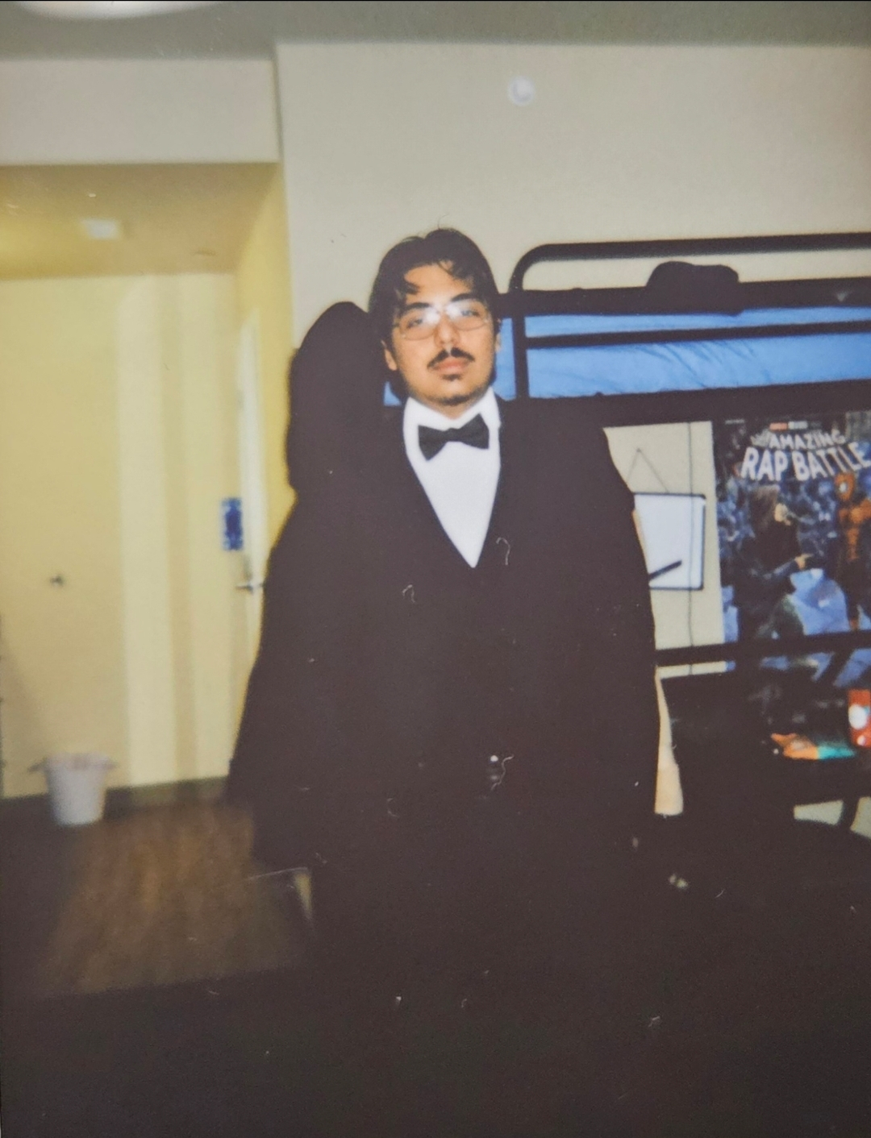
Name: Edgar Chavez
Major: Criminal Justice and Sociology
Blurb: Hello, my name is Edgar Chavez. I am a sophomore here at ISU and I am excited to be running for Cardinal Court Senator.

East Campus (Hewett-Manchester and Fell-School Street Apts.) Senator I
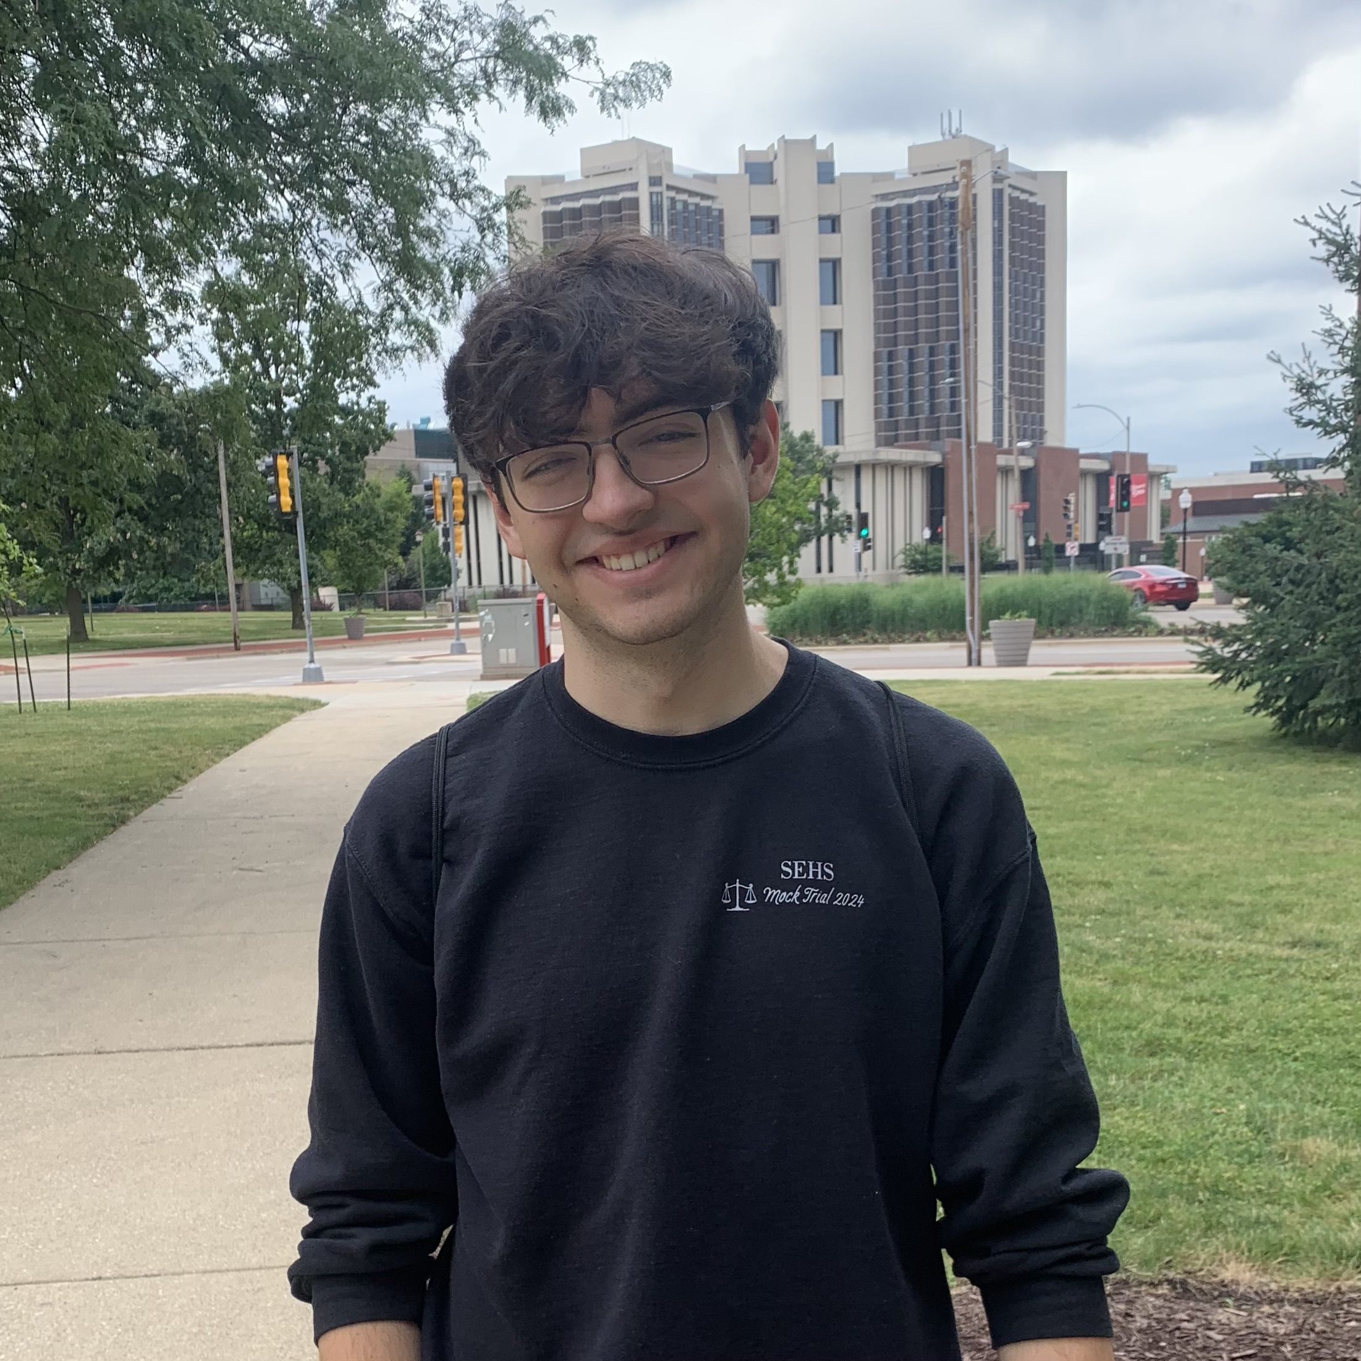
Name: Jack Stahl
Major: History
Blurb: Hi, I’m Jack, and I’m running to represent Hewett-Manchester and the Fell-School Street Apartments in the SGA! As your senator, I will work to ensure that our money is spent with students in mind, protect human rights, and increase participation in student government. ISU faces many issues right now, but as senator, I will listen to your concerns and fight to right any injustice I see on campus. Make sure to let your voice be heard and vote this March!

Tri Towers Senator I

Name: Hassan Hillard
Major: Political Science
Blurb: What’s up, Tri Towers! I’m Hassan, your future senator and a fellow resident. I know what’s working, what’s not, and what needs to change. I’m here to make sure our voices turn into action—whether that’s better resources, or just making life here run smoother. No empty promises, just results. Got ideas? Let’s make it happen.

Student Life Senator I
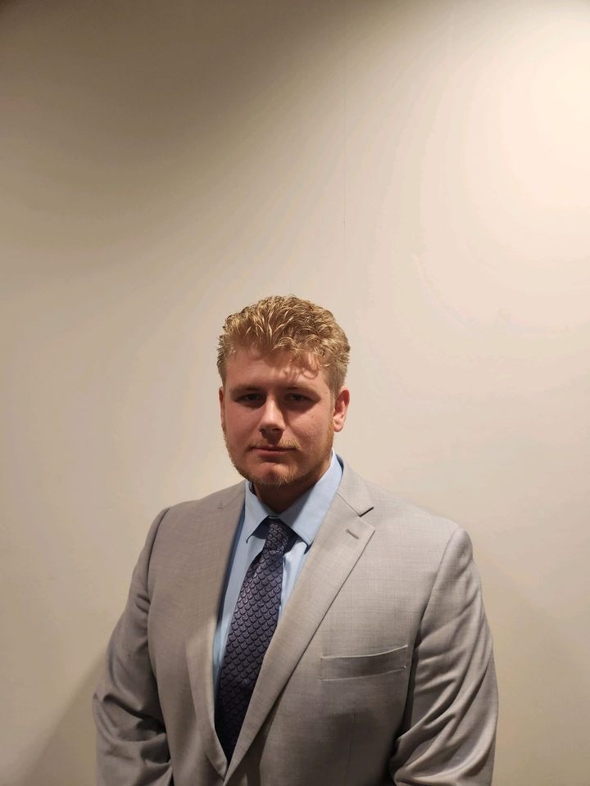
Name: Braden Beasley
Major: Political Studies and Legal Studies
Blurb: Senator Beasley is running to retain his position serving as your Student Life Senator. Looking forward to the 2025-26 academic year, Beasley plans to focus primarily on:

1) Continuing his previous work improving RSO systems
2) Improve outreach and communication between Student Life Senators and ISU Students to allow them to better get access to and use the resources at our disposal
3) Focus on creating new and engaging student experiences

Student Life Senator II

Name: Jamel Campbell
Major: Political Science

Student Life Senator III
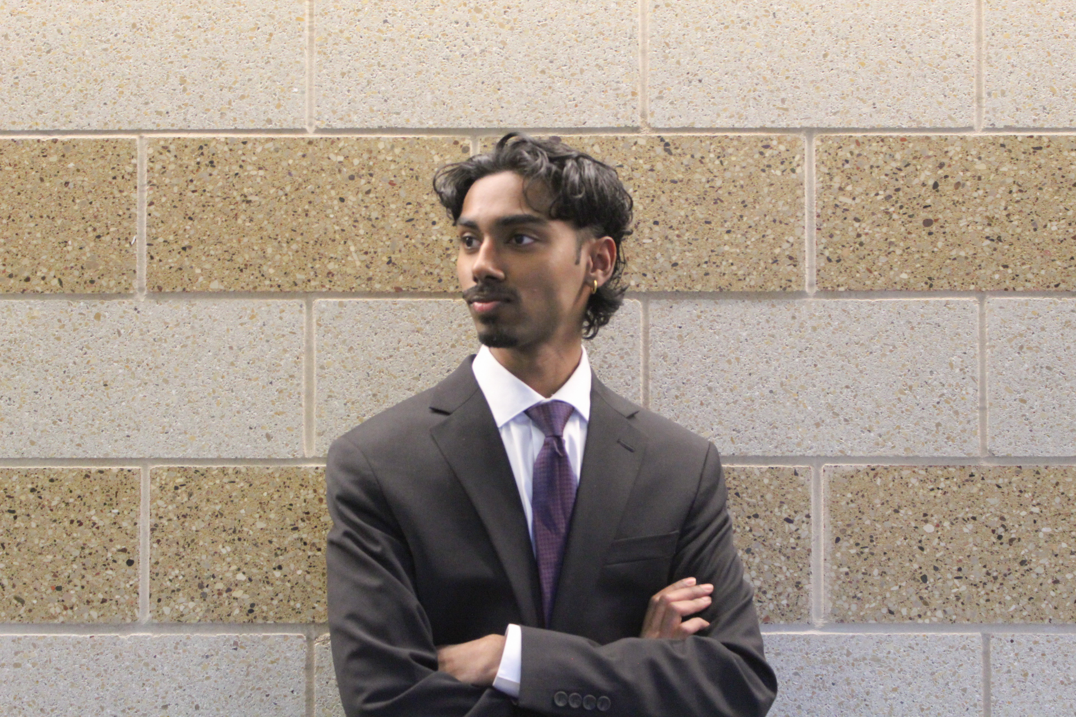
Name: Abhijith Jannu
Major: Economics and Cybersecurity
Blurb: As a dedicated student leader, I am passionate about enhancing campus life, increasing transparency between SGA and students, and ensuring all voices are heard. With experience in programming, leadership roles in various RSOs, and my current position as Secretary of Campus Inclusivity for SGA, I have worked to create meaningful initiatives that promote engagement, diversity, and student support. As a Student Life Senator, I will advocate for better student resources, including enhanced mental health services, career development opportunities, and campus engagement initiatives. I also plan to improve transparency by implementing open forums, having booths in the quad, and direct student outreach to ensure every voice is heard and valued.

Student Life Senator IV
Name: Kayla Wolf

Off-Campus Senator I

Name: Zakkary Clark
Major: Mass Media
Blurb: I am excited to announce that I will be running for an Off-Campus Senator position for the Student Government Association! I am currently a junior, but this is only my second semester at ISU. When I started school in the Fall, I knew right away that I wanted to become involved in something that would give me the opportunity to help make a difference on campus. I joined the Emerging Leaders Program (ELP) in the Fall and decided I would want to represent other off-campus students in the SGA. This is an exciting opportunity, and I look forward to campaigning and hopefully working more with the SGA!

Off-Campus Senator II

Name: Gareth Fullin
Major: Jazz Performance and Creative Technologies
Blurb: Hello, my name is Gareth Fullin, your future Off-Campus SGA Senator! I believe that the best way to bring about meaningful change as members of the campus community is through focused collective action. I intend to use my platform to promote the establishment of an ISU undergraduate student workers' union. I'll be working closely with undergraduate student workers and my colleagues to compile a list of demands and bring ISU and EMDH to the bargaining table. SGA is desperately lacking a Senator who advocates for student workers, and on that front, I pledge myself to be an agent of change.

Off-Campus Senator III

Name: Emma Susami

Student Trustee

Student Trustee I
Name: Ryan Russell
Major: Marketing
Blurb: Ryan Russell is a junior Marketing major. In his time on campus, he has served as a Student Life Senator in the Student Government Association, the Vice President of the University Program Board, the Vice President of Sigma Pi Fraternity, and is currently the President of the Interfraternity Council, and the President of Business Week. He is passionate about creating a safe and inclusive environment on campus while also making sure students' voices are being heard. He is thrilled to be able to work alongside many colleagues at ISU to continue to make this place, that he calls home, great!

ARH Executive Ticket

(President & Vice-President)

ARH Executive Ticket I

President
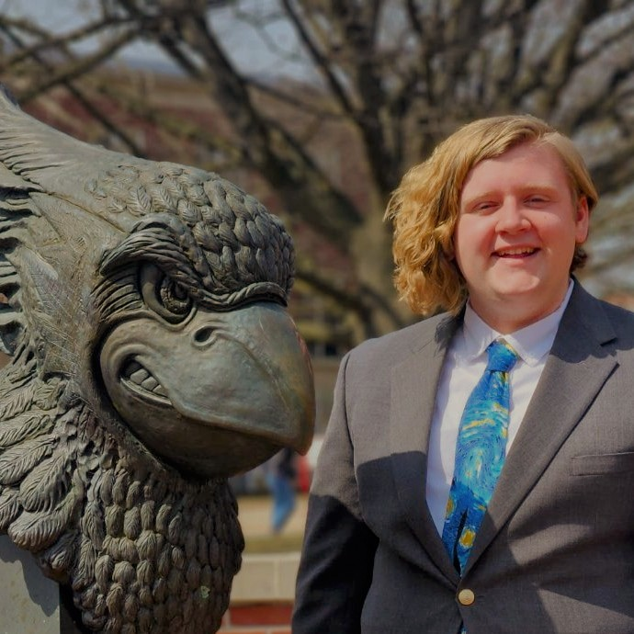
Name: Kyan Stuart

Vice President
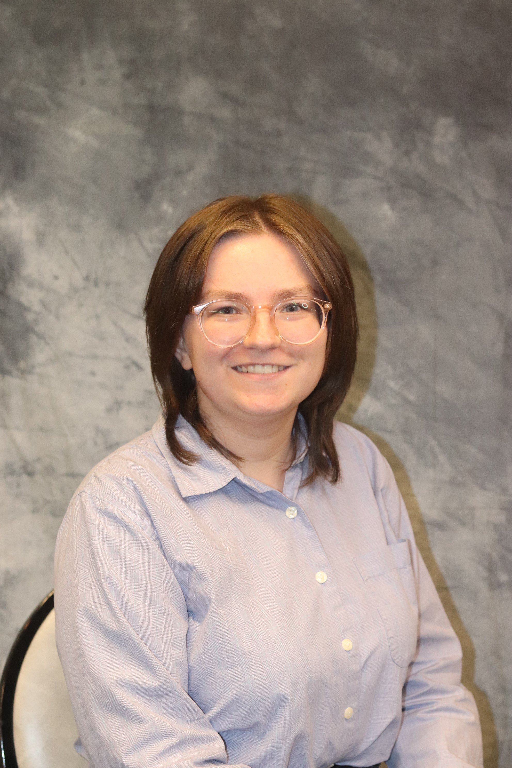
Name: Emily Cardinal
Major: Political Science and Economics
Blurb: My name is Emily Cardinal and I’m a freshman Political Science and Economics double major. I’m running for ARH Vice President because I believe I can bring a new perspective and expand ARH to other areas on campus. I’m excited to be working with other leadership associations and assisting with move in. Move-in is something I’m particularly excited about because I can ensure everyone has a smooth transition back on campus. I’m excited to see what the next academic year will bring and want everyone to know that I am here to make ISU a more welcoming place.

